TCS3351 CRYPTOGRAPHY AND DATA SECURITY
Tutorial 06

SYMMETRIC BLOCK CIPHER - MODES OF OPERATION

- Explain why modes of operation are needed if modern block ciphers are used for encryption.

Answer:
In real practice, most of the data to be encrypted is of variable size (normally larger than) other than 64-bit and 128-bit, as in DES and AES, respectively.
- Briefly explain Electronic Code Book (ECB) mode, list its advantages and disadvantages, and prove that the plaintext used by Alice can be recovered by Bob at the receiving end.

Answer:
The electronic code book (ECB) mode is a modern symmetric-cipher encryption in which plaintext is divided into the same size of $n$-bit blocks and is encrypted using the same private key independently. It is the simplest and most direct encryption mode in modern symmetric-key cipher. Fast and can be parallized.

The disadvantage of using ECB is that the pattern of the blocks is preserved, and the same blocks of plaintext will be encrypted into identical blocks of ciphertext. In addition, block independency allows an attacker to exchange/alter some blocks without knowing the key.

Given encryption $C_{i}={Enc}_{k}\left(P_{i}\right)$ and decryption $P_{i}={Dec}_{k}\left(C_{i}\right)$. Then

$$P_{i}={Dec}_{k}\left(C_{i}\right)={Dec}_{k}\left({Enc}_{k}\left(P_{i}\right)\right)=P_{i}$$

- Consider using the ciphertext stealing technique for Electronic Code Book mode.

- Show the diagram for encryption and decryption for the last two blocks.
- Show the equations used for encryption and decryption algorithm for the last two blocks.

Answer:
- Diagram of ciphertext stealing
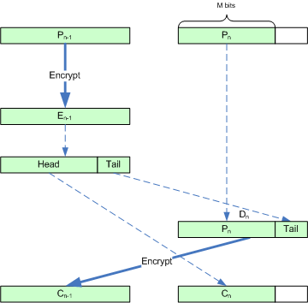

- Let block $P_{N-1}$ be $n$-bit and block $P_{N}$ be $m$-bit with $m≤n$. From the diagram above:
Encryption of block $P_{N-1}$: $C_{N}={head}_{m}\left(Enc\left(P_{N-1}\right)\right)$
Encryption of block $P_{N}$: $C_{N-1}=P_{N} | {tail}_{n-m}\left(Enc\left(P_{N-1}\right)\right)$

Decryption of block $C_{N-1}:$ $P_{N}={head}_{m}\left(Dec\left(C_{N-1}\right)\right)$
Decryption of block $C_{N}$: $P_{N-1}=Dec\left(C_{N} | {tail}_{n-m}\left(Dec\left(C_{N-1}\right)\right)\right)$

- (i) Briefly explain Cipher Block Chaining (CBC) mode, list its advantages and disadvantages, and prove that the plaintext used by Alice can be recovered by Bob at the receiving end.
(ii) Assume that bit 5 in ciphertext block 3 is corrupted during transmission. Identify the plaintext blocks affected by this.

Answer:
- The Cipher Block Chaining (CBC) mode allows each plaintext block to be exclusive-ORed with the preceding ciphertext block before being encrypted. For the case of the first plaintext block, an initial vector (IV) is introduced to complete the exclusive-OR operation. The CBC mode does not preserve the pattern of the encrypted block, and hence, identical plaintext block will be encrypted into different ciphertext block.

The disadvantage of CBC mode is that if the same IV is used for the first identical plaintext block, the same ciphertext block is obtained. In addition, an attacker can add additional ciphertext block to the end of the ciphertext stream, which results in alteration.

Given encryption $C_{i}={Enc}_{k}\left(P_{i}⊕C_{i-1}\right)$ and decryption $P_{i}={Dec}_{k}\left(C_{i}\right)⊕C_{i-1}$. Then

$$P_{i}={Dec}_{k}\left(C_{i}\right)⊕C_{i-1}={Dec}_{k}\left({Enc}_{k}\left(P_{i}⊕C_{i-1}\right)\right)⊕C_{i-1}=P_{i}⊕C_{i-1}⊕C_{i-1}=P_{i}$$

- On the Receiver side, bit 5 of the plaintext block 3 and plaintext block 4 may not be correctly decrypted since decryption requires exclusive-or operation with the previous ciphertext.

$$P_{3}={Dec}_{k}\left(C_{3}\right)⊕C_{2}$$

$$P_{4}={Dec}_{k}\left(C_{4}\right)⊕C_{3}$$

- Consider using the ciphertext stealing technique for Cipher Block Chaining (CBC) mode.

- Show the diagram for encryption and decryption for the last two blocks.
- Show the equations used for encryption and decryption algorithm for the last two blocks.

Answer:

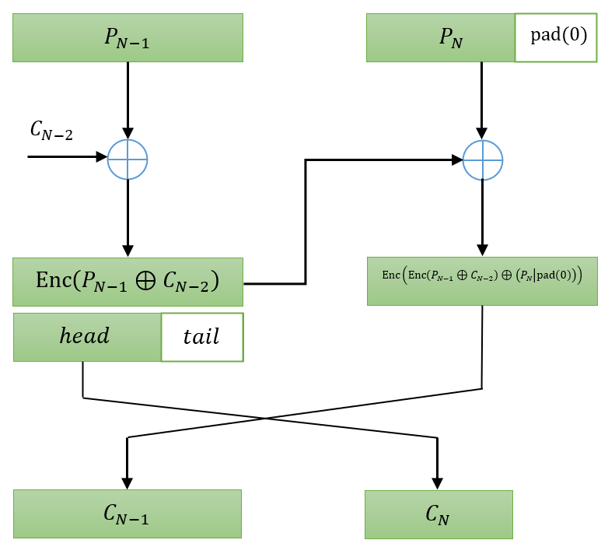

- Let block $P_{N-1}$ be $n$-bit and block $P_{N}$ be $m$-bit with $m≤n$. From the diagram above:
cm
Encryption of block $P_{N}$: $C_{N-1}=Enc\left(Enc\left(P_{N-1}⊕C_{N-2}\right)⊕\left(P_{N} | {pad}_{n-m}\left(0\right)\right)\right)$

Decryption of block $C_{N-1}:$
$$P_{N}=\left(Dec\left(C_{N-1}\right)⊕ Enc\left(P_{N-1}⊕C_{N-2}\right)\right)∤{pad}_{n-m}(0)$$
Decryption of block $C_{N}$: $P_{N-1}=Dec\left(Dec\left(C_{N-1}\right)⊕\left(P_{N} | {pad}_{n-m}\left(0\right)\right)\right)⊕C_{N-2}$

- Differentiate between Cipher Feedback (CFB), Output Feedback mode (OFB), and Counter (CTR) modes of operation.

Answer:
Cipher Feedback (CFB): In this mode, the $r$ least significant bit (LSB) of the shift register of $S_{i}$ comes from the previous $r$-bit ciphertext $C_{i-1}$. In other words, the bits of shift register are dependent on the bits of the preceding ciphertext $C_{i-1}$.

Output Feedback (OFB): In this mode, the $r$ least significant bit (LSB) of the shift register of $S_{i}$ comes from the previous $r$-bit temporary register $T_{i-1}$. In other words, the bits of shift register are independent on the bits of previous ciphertext, but the preceding temporary register $T_{i-1}$.

Counter (CTR): In this mode, no feedback is involved. The pseudorandom keystream is generated using a counter, but not the shift register.

- Divide the five modes of operation (ECB, CBC, CFB, OFB, CTR) into two groups based on the following:

  - Those that use the encryption and decryption functions of the underlying cipher and those that use only the encryption function.
  - Those that need padding and those that do not

Answer:
a. The modes that use the encryption and decryption functions of the underlying cipher: ECB, and CBC.
The modes that use only the encryption function: CFB, OFB, and CTR.
b. The modes that need padding: ECB, CBC, and CTR.
The modes that do not need padding: ECB (with ciphertext stealing), CFB, and OFB.

- Draw the diagram for encryption and decryption for the following modes of operation.
- Cipher Feedback Mode if the size of plaintext block (r) is equal to the size of the block used in block cipher (n)
- Output Feedback Mode if the size of plaintext block (r) is equal to the size of the block used in block cipher (n)

Answer:
- Encryption of $n$-bit plaintext block using CFB.

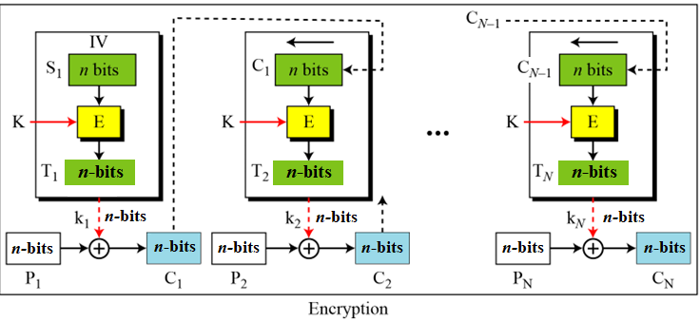
For decryption, I leave it as an exercise to you, try to reverse the diagram above.

- Encryption of $n$-bit plaintext block using OFB.

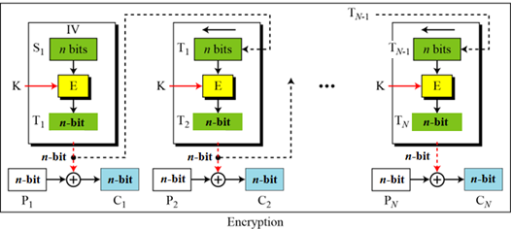

For decryption, I leave it as an exercise to you, try to reverse the diagram above.

References:

1. Forouzan, B. A. & Mukhopadhyay, D. (2015). Cryptography & Network Security (3rd ed.). McGraw-Hill.

2. William Stallings, “Cryptography and Network Security – Principles and Practice”, Seventh Edition, Prentice Hall, 2017

